Datanet at ARK
On-Boarding Guide and Rules of the DC

Address: ARK Data Centres, Building A101, Cody Park South Gate,
Old Ively Road, Farnborough, Hampshire, GU14 0LH
(tip: address details and map here: https://www.datanet.co.uk/ark-address/

Datanet Support 24x7 T: 01252 813396 Support@datanet.co.uk
ARK Service Desk 24x7 T: 01225 818999 ASD@arkdatacentres.co.uk

ARK is certified to the following standards:
• ISO 27001 (Information Security Management System)
• ISO 14001 (Environmental Management System)
• ISO 9001 (Quality Management System)
• ISO 22301 (Business Continuity Management System)
• ISO 50001 (Energy Management Systems)
• PCI DSS Version 3.2.1 Category Level 1 Service Provider

Datanet is certified to the following standards:
• ISO 27001 (Information Security Management System)

Confidentiality: whilst on site in our data centres, any information (verbal, written, electronic or observed) should be treated as confidential and not retained or disclosed unless you have written agreement from Datanet.co.uk Limited.

On behalf of the Datanet Team, Welcome to the Datanet at ARK Data Centre and thank you for coming on the journey with us to the ARK Data Centre, Farnborough.

This guide lists:

At a glance summary of the ARK Farnborough data centre Page 1

Connectivity Solutions, options for connecting your rack to our core Page 2

Positioning of devices, airflow considerations Page 6

ARK Health & Safety and Data Centre Rules Page 7

At a glance summary of the ARK Farnborough data centre

- There are 6 large data centre buildings at ARK Farnborough, A101 to A106, Datanet have two independent data halls in A101. Both halls are on the first floor and are named DR2 and DR4, each containing about 150 racks shared with Capita. Your rack will be in DR2 or DR4 and you will be shown how to get to the front and back of your rack during your first visit when you arrive to complete this on-boarding process and get your permanent security access.
- Security arrangements at ARK are strict. Once you have completed the on-boarding process (requires Government issued photo ID such as your passport or driving licence) and you have been issued a permanent security access card, you can come and go 24x7 without notification, but you must bring your security access card and car pass for each visit. Three factor authentication is used: card, pin and biometric fingerprint.
- Visitors (somebody without a permanent security access card) will only be allowed access to A101 DR2 or DR4 by arrangement with Datanet at least one business day in advance and on the day must be accompanied by you (a permanent security access card holder). On the day of their visit your visitor will be asked, at the main security reception, for Government ID to gain access, acceptable Government ID is a passport or driving license in their name. Even if your visitor already has arranged access to other areas of A101 you must advise Datanet if your visitor wishes to have access to DR2 or DR4. Emergency access for support engineers e.g. Dell, HP etc. can be arranged as an emergency exception.
- Storage of non IT equipment (flammables, paperwork, packaging etc.) is only permitted in suitable flame retardant storage e.g. rack drawers: https://www.amazon.co.uk/19-inch-2u-Rack-Drawer/dp/B006BVXQDU or https://cpc.farnell.com/pulse/rd2s/rack-drawer-2u-210mm/dp/DP32516 these are examples, please make your own choice
As the Datanet racks are particularly large at 47U x 800w x 1200d there is adequate room for rack drawers at the back of the rack, just be mindful not to restrict the air flow.
- Any cabling between racks must be arranged by Datanet and must use the overhead cable trays. Leviton (Brand-Rex) or Excel high performance smoke and halogen free cabling must be used between racks and anywhere outside of your rack.
- Datanet provides a pair of APC 8853 32A PDU’s for your use (36xC13 & 6xC19), we require permanent use of the data port for power readings. You can provide your own PDU’s however, please discuss suitability with us as we will still need access for power readings over the network and your PDU will need to be compatible with our power measuring solution and be a proper fit for the rack. The pair of PDU’s derive their power from separate A/B power feeds, best practise is to supply your (dual powered) critical equipment from separate PDU’s. If you do not have equipment with dual power supplies you may wish to add a static transfer switch (STS or ATS).
- All racks must be fully blanked to ensure cool air passes through your devices and no cool air escapes into the hot aisle! We can provide air blanking covers to fill any voids in your rack, and if you remove kit, remember to blank the space. Edge brush strips are provided for cables etc. that pass through the sides and must also be used to ensure cool air does not escape into the warm aisle (refer diagram on page 6).

- Do not leave any tools or equipment outside of your rack or in the aisles for longer than necessary and always leave the area tidier than you found it.

- Extensive mechanical/electrical works such as cabling new rack, moving large amounts of equipment from one rack to another or around the data halls may require RAMS (Risk Assessments & Method Statements) please discuss with Datanet.

- All delivery or collection requests must be advised to Datanet by 17:30 the previous business day, please email Support@datanet.co.uk. The delivery address is: Your-Company-Name, c/o DATANET.CO.UK, ARK Data Centres, Building A101, Cody Park North Gate, Bramshot Lane, Farnborough, GU14 0LH The North Gate entrance is the main entrance for van and lorry deliveries and for access to the loading bays on weekdays Monday to Friday between 7am and 7pm. Deliveries outside these times can be arranged with security at the main South Gate. More detail and maps here: https://www.datanet.co.uk/ark-address/

- For your convenience, there is a kitchen with tea and coffee facilities, additionally there are toilet and shower facilities. There is also a Client Room #4 which you can use for working on your equipment and you can use the server lift and crash carts, though you may need to book these latter two in advance.
- You can also book the meeting room for your client or staff meetings, this is on a first come basis so please do book with Datanet well in advance: Support@datanet.co.uk.

Internet Connectivity Solutions, options for connecting your rack to our core

Your rack will be provided with a pair of Internet connections and we recommend that both are connected to your equipment for resilience. All connections are presented on RJ45 over CAT6e. 10Gb ports are available for Ultra full racks, whilst ⅓^{rd} racks are provided with 1Gb connections.

In order to provide our customers the best redundancy options and to protect our network we have outlined our recommended configurations for your internet access feeds.

Please review this following section and select the most appropriate option for your needs. You must let us know of your selected choice before you plan to move into your rack so our engineers have time to install your cabling and configure and test your solution.

We encourage you to go live during business hours so our network team will be able to assist you should an unexpected issue with your configuration occur. Should you have any trouble deciding which option is the most suitable, please contact Support@datanet.co.uk and we will arrange for a member of the network team to discuss your options with you.

Option 1 (not recommended for mission critical services)

Using only one of the pair of Internet connections from Datanet’s core network to your rack. This can be used with your router, switch or firewall. You can have your public subnet assigned to it or use a /30 or /31 and have another larger public subnet behind your device (customer device providing L3 functionality). Gateway resilience is provided using a VRRP configuration on Datanet’s core routers. It is worth noting that Datanet has loop and root protection in place on all switch interfaces as default.

Datanet
Customer Network

L2
Customer Router

L3

L3
L2
Customer Firewall

L3
L2
No STP
Customer Switch

Availability: Location | Full Rack (47U) | ⅓^{rd} Rack (15U)
Datanet at ARK | ✓  | ✓ 

Option 2

The following connectivity options provide dual feeds from our core switches into your rack, default gateway services are provided by a VRRP setup on Datanet core. We also support this design to customer’s switches, but the customer must ensure both feeds are in the same Layer two segment on the customer’s network for VRRP to converge correctly.

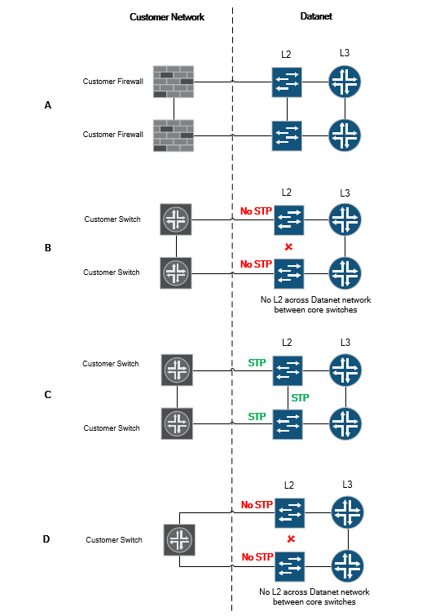

Availability: Location | Full Rack (47U) | ⅓^{rd} Rack (15U)
Datanet at ARK | ✓  | ✓  (Option A Only)
Option 3

Datanet provides dual feeds from separate core switches and each of these ports are configured as /30 or /31 subnets. The customer’s main subnet is then routed from Datanet to the Customer Edge. Datanet will configure static routes to each customer router which will provide inbound redundancy if the customer router fails or the feed goes down. The customer announces their subnets to Datanet using BGP. The BGP configuration can be setup by using Private AS numbers provided by Datanet or by using the customer’s Public AS number.

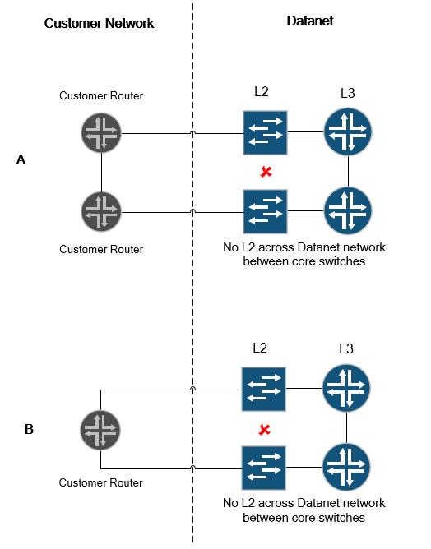

Availability: Location | Full Rack (47U) | ⅓^{rd} Rack (15U)
Datanet at ARK | ✓  | ✓ 

Positioning of devices, airflow considerations

For the most efficient cooling, we require air flow from cold aisle to the hot aisle such that the front of your devices would be facing the cold aisle drawing in cool air and your devices exhaust the warm air to the warm aisle. This is front to back air flow which ensures efficiency, reduces environmental impact and keeps cooling costs down.

Furthermore, please ensure there are no air gaps allowing cool air to escape through to the warm aisle. Please use the air blanking covers provided or discuss your needs with Datanet. Edge brush strips are provided for cables etc. that pass through the sides and must also be used to ensure cool air does not escape into the warm aisle (refer diagram). If you remove a device you must insert air blanking covers, ask Datanet we can help with these. All racks must be fully blanked to prevent cool air escaping to the hot aisle!

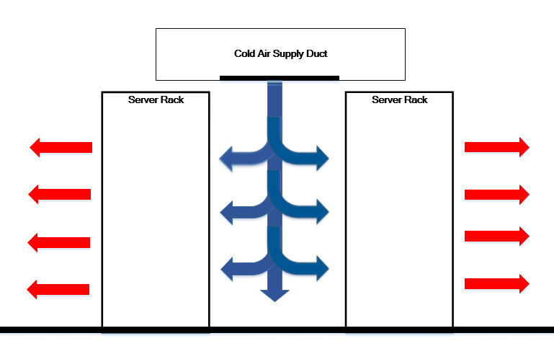
Warm aisle Cool aisle Warm aisle

- ALL hardware must be unpacked in the delivery area or the client room before being taken into the data centre halls. Packaging left in the delivery area will be removed and disposed of by ARK staff. No packaging materials or food and drink can to be taken into the data centre halls.
- Installation of your equipment must be carried out in accordance with Health and Safety guidelines (refer page 7).

Working and welfare facilities
Client Room #4 (first floor, opposite DR2, DR4) is available for working on and preparing your equipment and you can use the server lift and crash carts, though you may need to book these in advance. For your convenience there is a kitchen with tea and coffee facilities, also toilet and shower facilities.

Please read the attached Important “Rules for working in the DC” and “Health & Safety Induction” to keep you and all our visitors safe and to save time at reception completing the access protocols:

ARK Rules for working in the Data Centre (double click):

ARK Health & Safety Induction (double click):
Accidents, Emergencies or Health & Safety matters should be reported to the:
ARK Service Desk T: 01225 818999 or ASD@arkdatacentres.co.uk

Datanet Support 24x7 T: 01252 813396 Support@datanet.co.uk
ARK Service Desk 24x7 T: 01225 818999 ASD@arkdatacentres.co.uk

ARK normal hours: 06:30 to 19:30
ARK out of hours: 19:30 to 06:30
ARK alternative security numbers: 01225 818970 / 818972 / 818949

ARK duress number, in the event you want to alert security to a duress situation:
At the keypad enter your pin code with the last digit increased by 1, e.g.
usual PIN: 3052 duress PIN: 3053
usual PIN: 7890 duress PIN: 7891
usual PIN: 1369 duress PIN: 1360 (only the last digit increases)

Address: ARK Data Centres, Building A101, Cody Park South Gate,
Old Ively Road, Farnborough, Hampshire, GU14 0LH
(tip: address details and map here: https://www.datanet.co.uk/ark-address/

